**Contacts test case**

**Goal:**

As a tester, I want to verify if the contact form is correctly working and if the formulary is filled with gender, name, email, phone number, and personal questions.

**Background:**

Contacts page is responsible to save the client information and questions and report to the costume service .

**Steps to Reproduce**

1. Go to <https://www.find-a-house.nl/en/home> and click on the menu bar

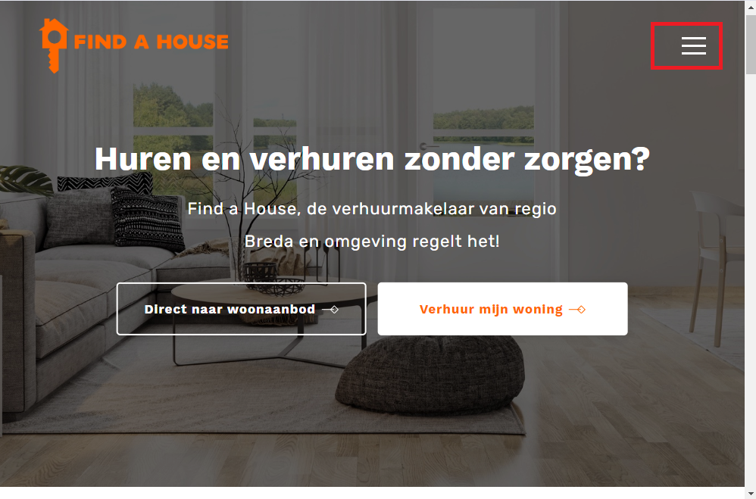

2. Click on the “Inloggen” Button to open the Login form.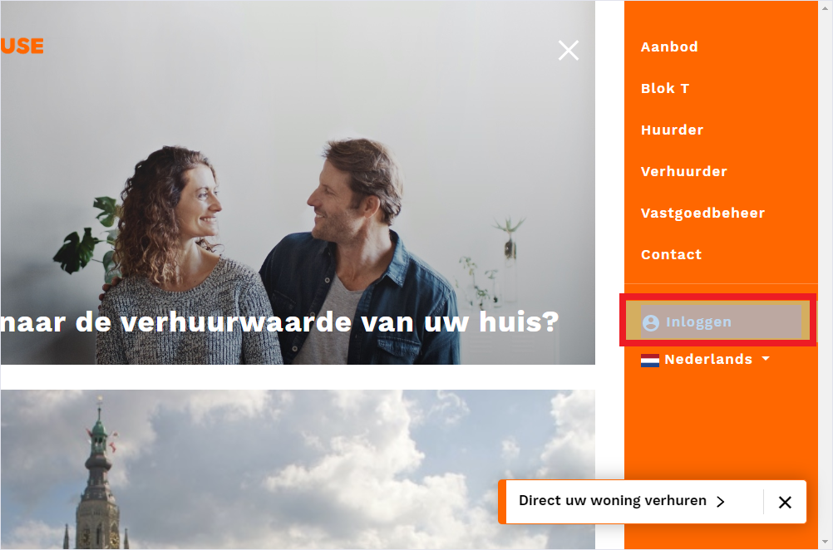

2. type an email account and password and click on the button “Inloggen.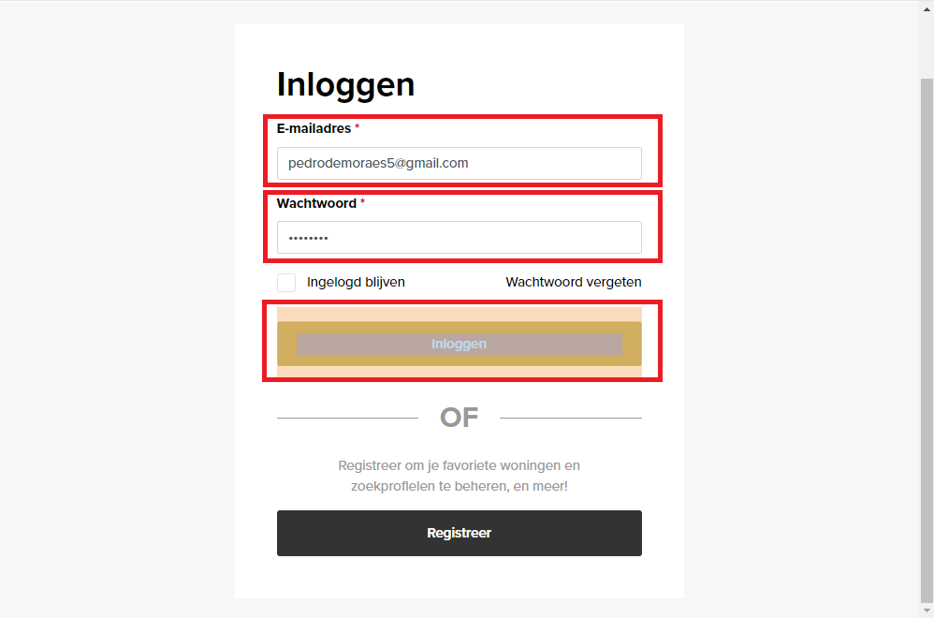

3. The dashboard page will be opened, then click on the button “Terug Naar de website”.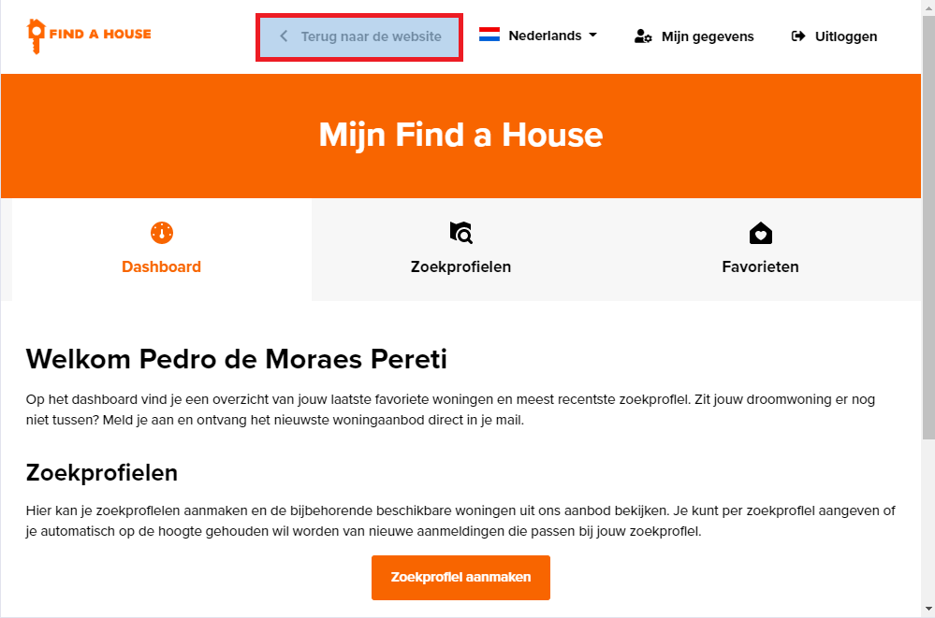

4. The page will be redirected to the main menu.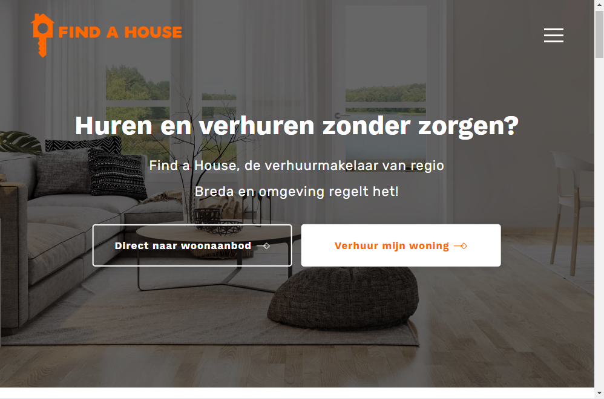

5. After returning to the main menu, the “Bar menu should” be opened again.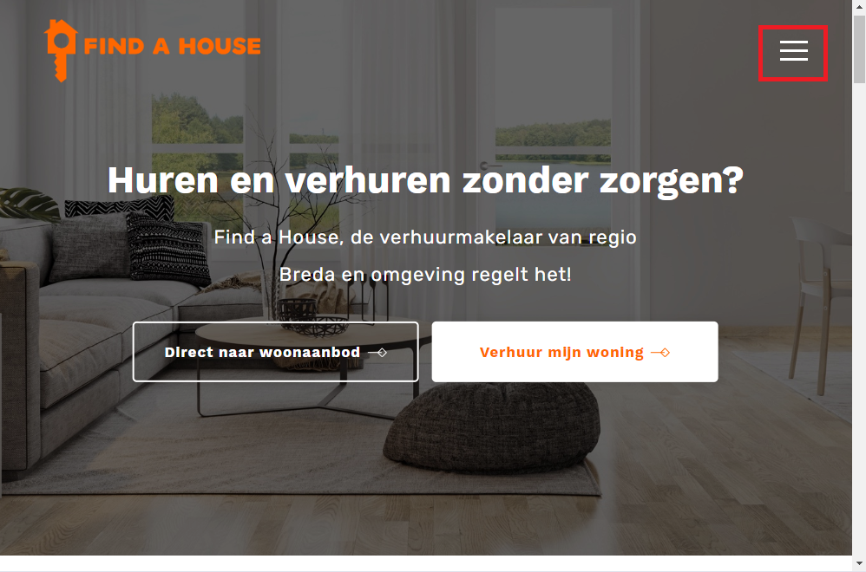

6. The Menu bar will open again, click on the Contact button.

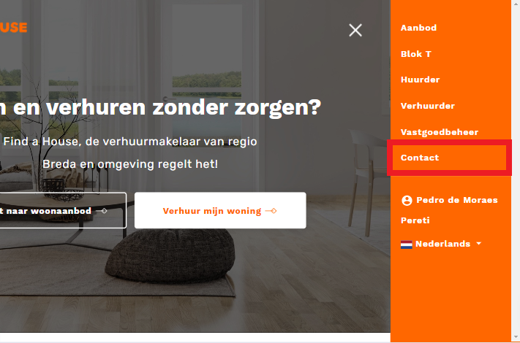

7. The page Contact should be open.

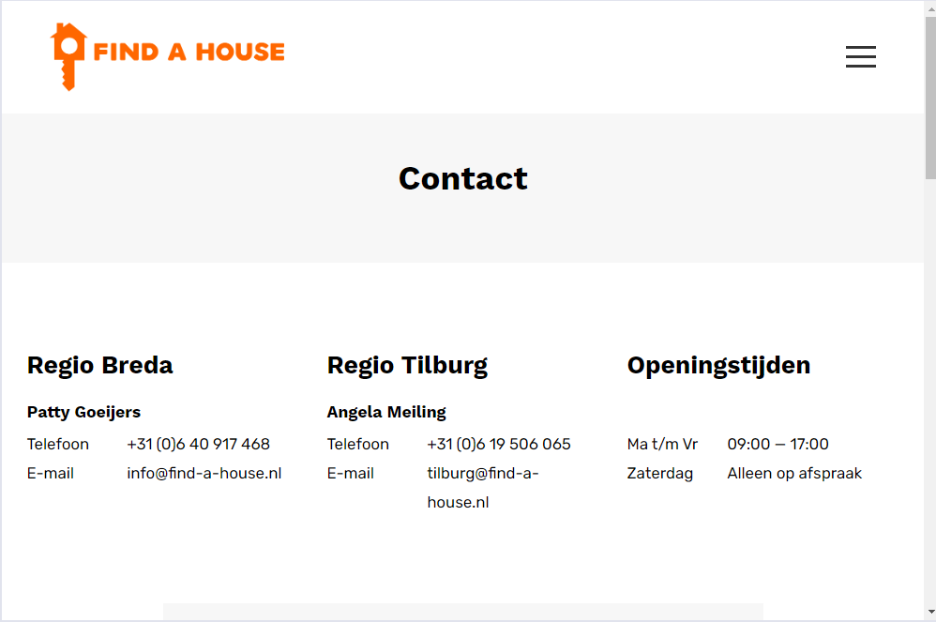

8. After the Contact page is open, fill the form, select the check box and click on the button “Verzenden ”

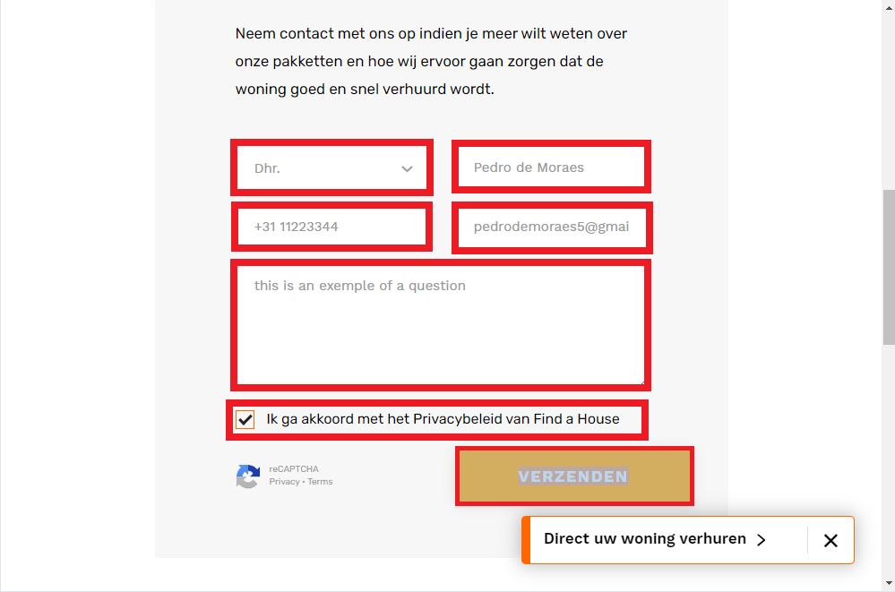

By the end of the filled form, the Contact Automation test is finished.